BSCS FINAL PROJECT

Software Design Specification

THE SHIPPING SAINTS



Project Advisor

Presented by:

**Faculty of Information Technology**

**University of Central Punjab**

Software Design Specification

SDP Phase II

THE SHIPPING SAINTS

Advisor

|  |  |
| --- | --- |
|  |  |

Table of Contents

Table of Contents i

Revision History ii

1. Introduction 1

1.1 Product 1

1.2 Background 1

1.3 Objective(s)/Aim(s)/Target(s) 1

1.4 Scope 2

1.5 Business Goals 3

1.6 Document Conventions 3

1.7 Miscellaneous 4

2. Overall Description 5

2.1 Product Features 5

2.2 Functional Description 5

2.3 User Classes and Characteristics 7

2.4 Design and Implementation Constraints 7

2.5 Assumptions and Dependencies 7

3. Technical Architecture 2

3.1 Application and Data Architecture 2

3.2 Component Interactions and Collaborations 4

**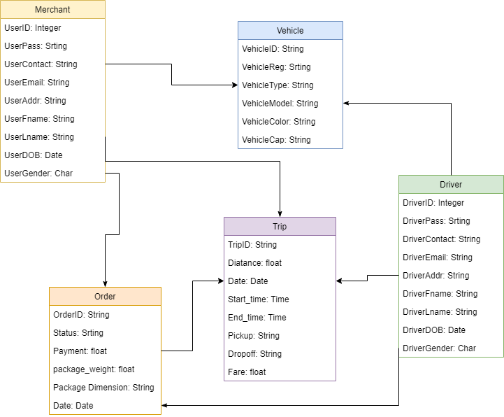** 5

3.3 Design Reuse and Design Patterns 5

3.4 Technology Architecture 5

4. Screenshots/Prototype 7

4.1 Workflow 7

4.2 Screens 7

4.3 Additional Information 18

5. Other Design Details 19

6. Revised Project Plan 19

7. References 20

Appendix A: Glossary 21

Appendix B: IV & V Report 22

Revision History

|  |  |  |  |
| --- | --- | --- | --- |
| **Name** | **Date** | **Reason For Changes** | **Version** |
|  |  |  |  |
|  |  |  |  |

# Introduction

## Product

Now days there are many problems of deliveries in ecommerce industry.

* Late delivery is the biggest problem with current delivery system; our idea is for solving this problem.
* Delivery charges are high, current charges are about Rs.200, because of this the profit margins of ecommerce storeowner are reduced.
* Payment clearance of ecommerce storeowners from shipping companies are too late.
* The file of exported orders from the site will be upload on our application, so the user would not have to enter orders manually, which is a time consuming process.

## Background

Our project targets the local ecommerce industry for the fast and affordable delivery cost for merchants. We will make an independent platform where a store owner deliver his/her orders they need to open the mobile app and put the order shipping details there according to the limit of one rider and then press the done and then the delivery riders who are register with our system received request notification for order, if he accepts the request he would have to pick-up order from the warehouse/store and update the status to parcel collected, then our app generate a shortest path using Artificial Intelligence from warehouse/store Destination and calculate the fare based on distance and parcel weight to all destinations, by this the cost is also reduced and when rider deliver a parcel he will update the status to order delivered and receive cash from customer, and if the customer doesn’t receive parcel the status will be updated to not received

## Objective(s)/Aim(s)/Target(s)

Our app in made for your e-commerce platform. With a moto of fastest delivery within 24hours and may be less than an hour whose compatibility for Shopify and WordPress, as an E-Retailer you can rest assured that no matter what your E-Store platform is. Once you click on an order in your E-store dashboard, that order seamlessly falls into our shipping application where you can process it by performing

Generate Order and search for rider

Rider will pick up the items

Track the order

Bulk orders

Add or remove products from within the order

Leaves customer service or operation specific comments against the order

Shortest path selection

Order status and Payment received notification

You can also view your outstanding payments from and review your account statements and history

## Scope

Basically it an app and web based application that delivers the products at your door step within one day in city. You can use our app for the below mentioned points

* For overnight delivery of urgent shipments across the country
* Safe and reliable delivery of valuable parcels across the nation within 48 hours
* Send heavy shipments at low prices by road nationwide
* Take advantage of quick, reliable deliveries within days to any corner in the country
* Reliable and speedy delivery of cargo to anywhere in country
* We go that extra mile when it comes to delivering your shipments.
  + Special handling & fragile shipments
  + Time definite shipments
  + Holiday & weekend deliveries
  + Individually customized solutions with us can package, protect and transport your valuables wherever you want.

Offering hassle-free payments, through our convenient collection solutions. The rider will submit the collected cash to the company’s Bank Account, then company will transfer the payment to merchant.

We can provide complete delivery solution for all your ecommerce needs with an matchless service. Being extremely customer focused, we are highly adaptable when it comes to our customer’s requirements. We can offer time-sensitive deliveries within a day, and deliveries outside normal business hours, we can deliver your shipment specifically where you want it, when you want it.

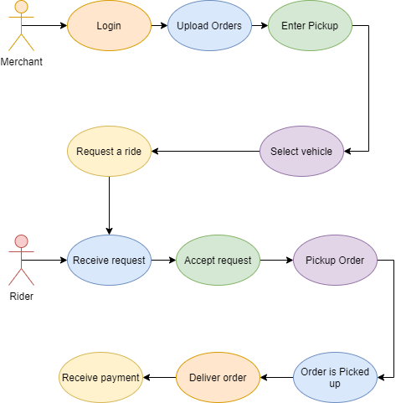

## Business Goals

As we, all know about the e-commerce, industry is growing very rapidly. So every startup or business modal which is related to e commerce is must be beneficial. Because from last 2 – 3 years this industry is setting up new trends and enabling entrepreneur to make millions of dollars so if we can overcome the major issue which is delivery on time so our idea must be successful and if it will become successful then it must have a great business potential of making millions

## Document Conventions

* Font for the description is Arial
* Arial size is 11.
* Heading font is Times, Size 18.
* Size for Sub-Heading Times, Size 14.
* Line Spacing between text is 1.5.

## Miscellaneous

As we know, some private entities are offering delivery, which is less, then an hour. However, these all are centralized companies but we also making our platform much efficient from which it will match the delivery time as we are not a ecommerce company itself but we will do this for our merchant by making our system as much efficient as we can.

# Overall Description

## Product Features

The main feature of product is that

* You simply add your order file there
* It will automatically arrange order in such a way that creates less time and fuel consuming path
* You simply select rider according to your convince
* Rider will accept your request and reach there
* You can have life location functionality with currently and the next order that is going to deliver location
* You can track them easily

You can have your payment and detail there after being updated each order deliver

## Functional Description

The rider will have mobile app through which he register himself. And store owner have mobile app / web app where he can place the order for delivery. If the storeowner has 10 or 20 order, we will make our app, which supports different cms order files to be uploaded on our system and all the orders details added to database automatically no need of placing details one by one. Our app have different transportation vehicles categories depending on the dimensions of product. Which includes bikes, autos, and pickups, next our app generate a shortest path using Artificial Intelligence from warehouse/store to destination, this is for the rider benefits as we have 10 orders so our system automatically makes the shortest path from where all the orders can be delivered in shortest time and efficiently. so it can be a time and fuel efficient service. When rider deliver a parcel he will update the status to order delivered and receive cash from customer, and if the customer does not receive, parcel the status will be updated to not received, the status notification and fare for each delivery will send to owner. And in the last if the orders are on cod then the cash should be clear at the end of the day and the payment clearance issues also be solved because of this.

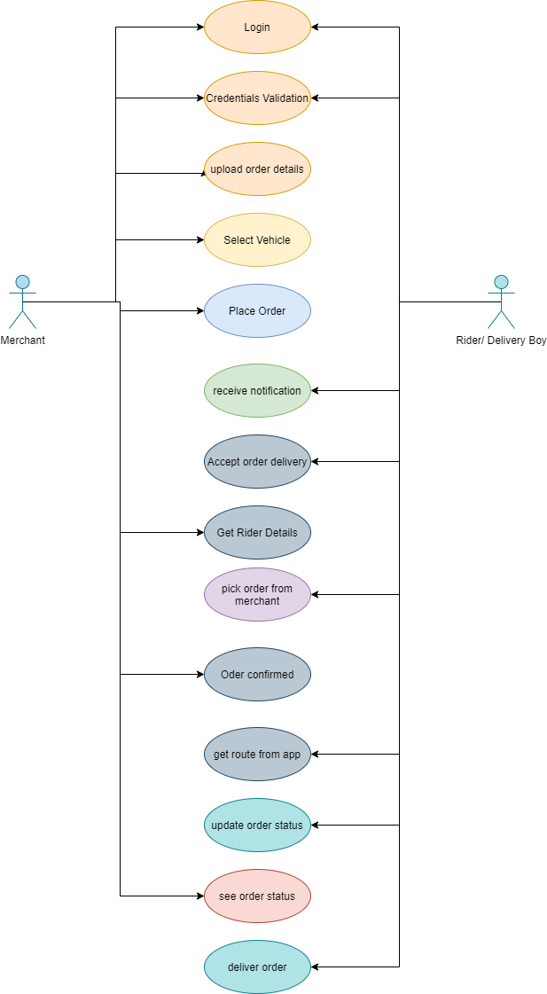

## User Classes and Characteristics

**We mainly have two primary user classes**

**Merchant:**

The ones who is going to use our app for delivering of her products

**Driver:**

The one who is going to deliver the products

## Design and Implementation Constraints

We always focus on the security of our customers so in this regard we have developed a security plan   
 for drivers:

They need to visit our office with police verification from his local area and 2 guarantor then we will sign an security agreement with them

Plan for merchant:

The only need to register their shop/business with our platform and the will be given an agreement to sign

## Assumptions and Dependencies

We assume that if number of rider are busy than fair would be increased, in case if no user is available in your area the you will have to go to open booking option where the ones who accept the ride will receive extra charges, if you book on faster delivery then you have to pay double charges.

# Technical Architecture

|  |  |
| --- | --- |
| * Is the system custom-built? COTS? | Yes this system is custom built |
| * What are the major application components? | We have two major component  RIDER:  The one who deliver the order  MERCHANT:  The one who place the order  AI algorithm for selecting path |
| * What data does the current system collect and manage? | It collects the information of riders and merchant  On basis of riders location it will tell where the rider is currently located  It tells the administration where we need more riders |
| * What is the basic application architecture (layered client/server, etc.)? | It is Client/Server architecture. |
| * What programming language is the current system built in? | React native |
| * What is the hardware platform that supports the current system? | Android |
| * What database platform supports the current system? | Firebase |
| * Does the system have an end-user interface? If so, what type of user interface? (e.g., browser based thick client). | It will have android application for riders and merchant |
| * What is the basic network architecture (e.g., available on LAN, WAN, Internet)? | Internet based network architecture |
| Where is the system hosted (e.g., Enterprise Data Center, Other CMS Data Center, External Data Center | External Data Center |

## Application and Data Architecture

ER DIAGRAM:

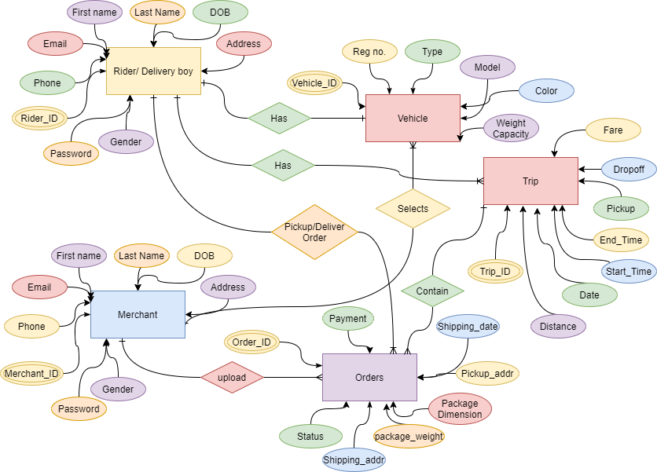

## C:\Users\Muhammad Muneeb\Downloads\DFD_Diagram.pngComponent Interactions and Collaborations

## C:\Users\Muhammad Muneeb\Downloads\FYP_ClassDiagram.png

## Design Reuse and Design Patterns

*<Identify and state any reuse during development of the system>*

## Technology Architecture

We are using different technology for our system and different algorithms from where our system would be more efficient and more productive. So all the entities, which we want to target, will use us happily so we are using firebase database, as this is one of the most secure database. Moreover, using react-native Framework as this is one of widely used frameworks and does not affect our system performance. In addition, after this we are going to use travel sales man problem for finding best and shortest path for our rider from where the deliveries would be delivered as soon as possible. And we also put some filters like when there are rush hours, we also provides best routs where our riders delivers without facing rush and things like that and once the rider will called by the store merchant and store merchant have more number of orders. Then the vehicle nature then it will automatically shifted to the other respective vehicle and this shifting will be calculated based on area of.

DATABASE: FIREBASE

Framework: REACT NATIVE

APP FOR RIDER

APP FOR MERCHANT

# Screenshots/Prototype

## Workflow

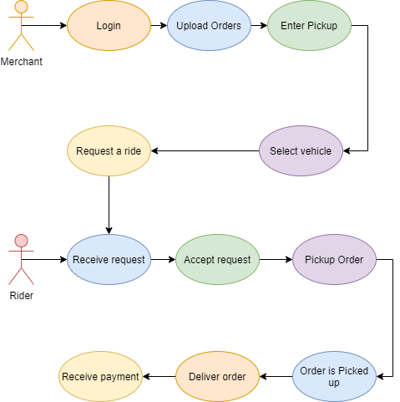

## Screens

MERCHANT SCREENS

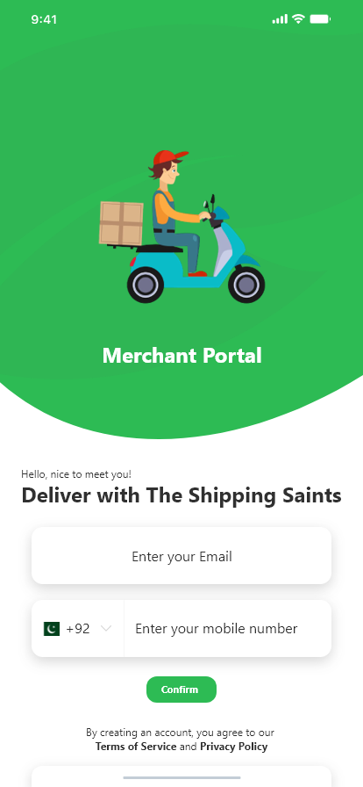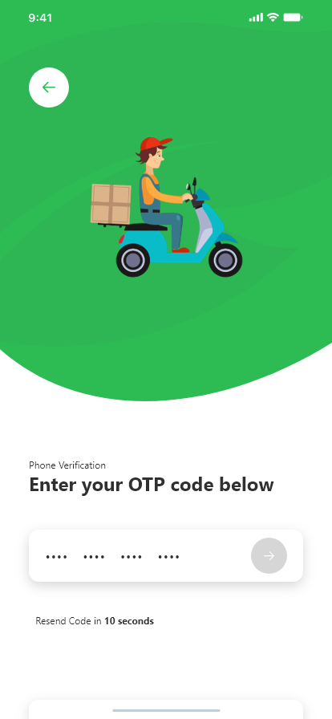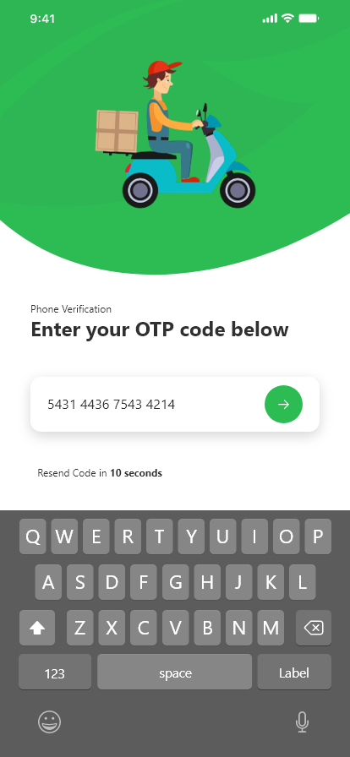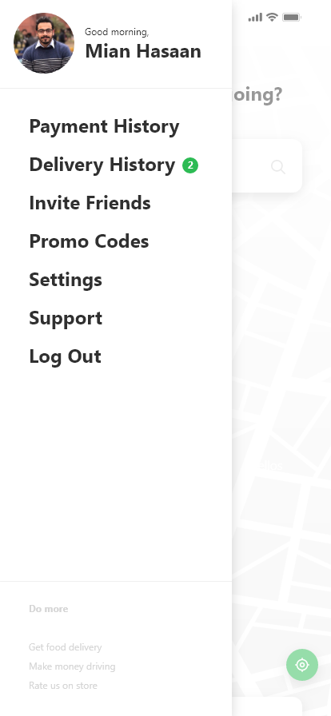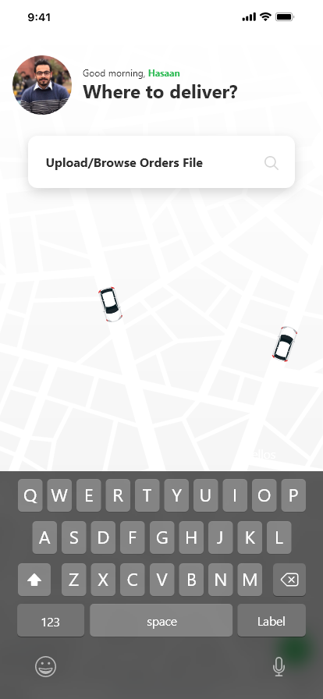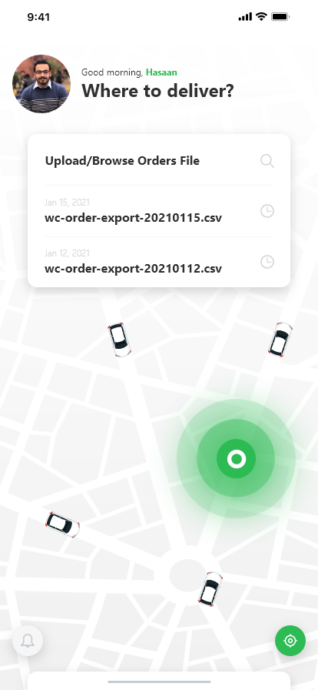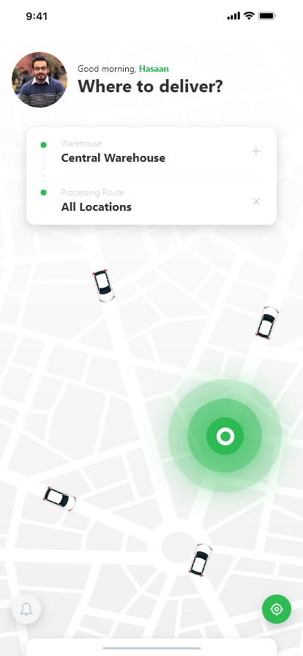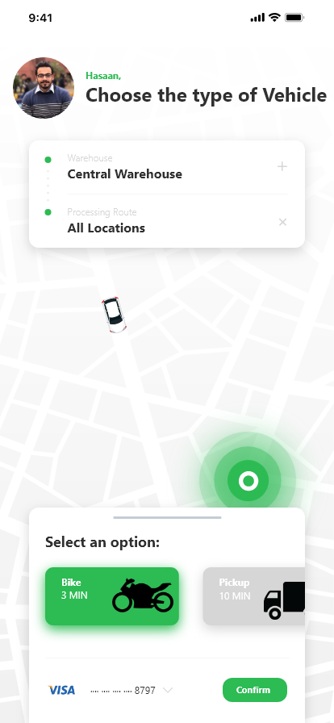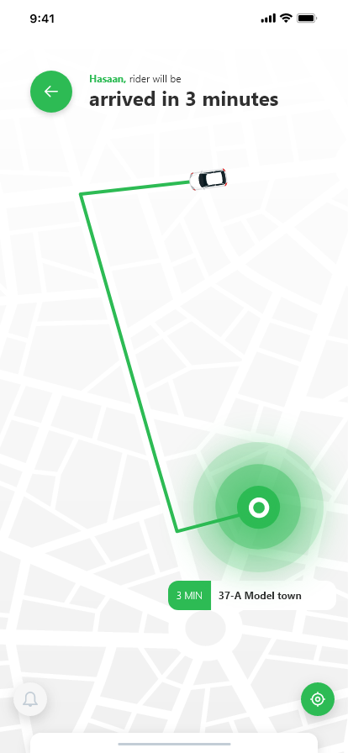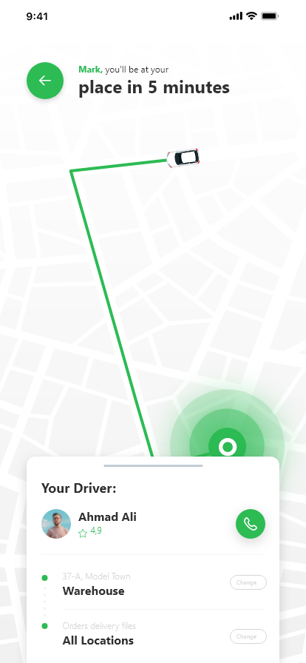

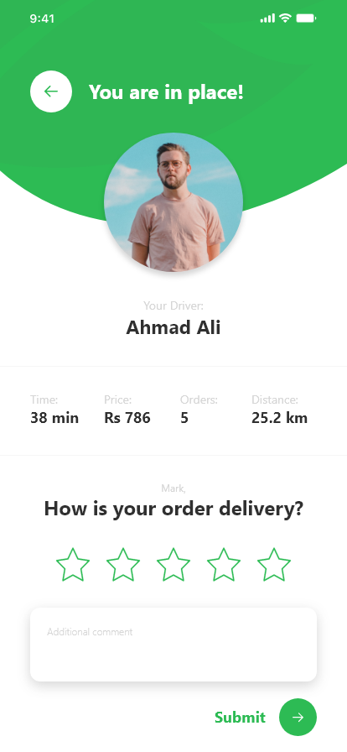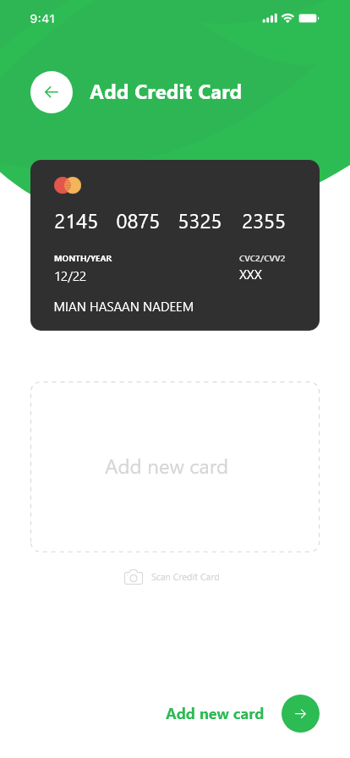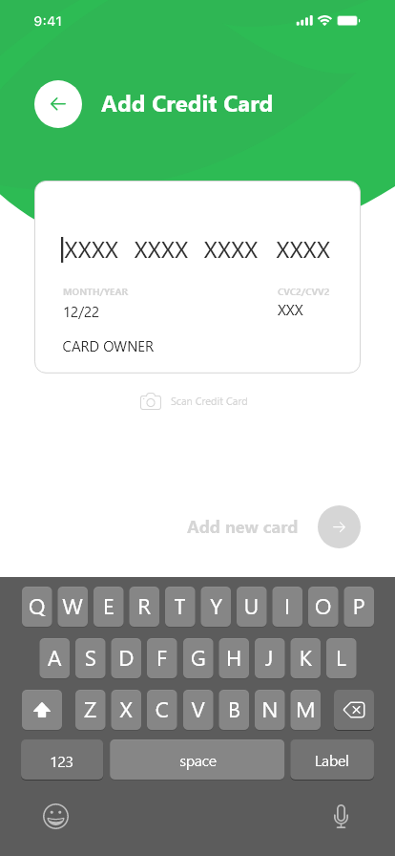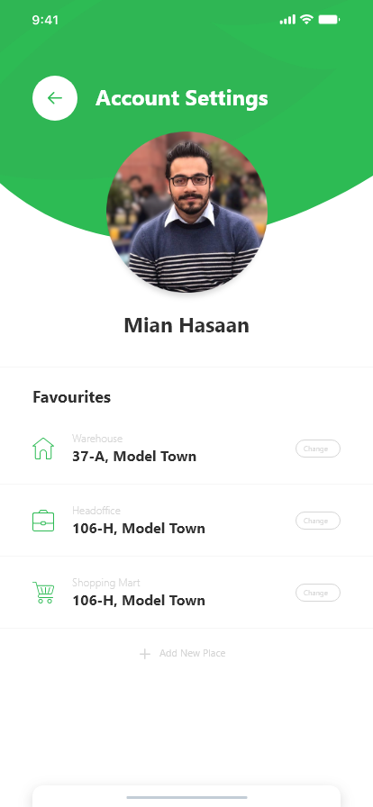

RIDER SCREENS

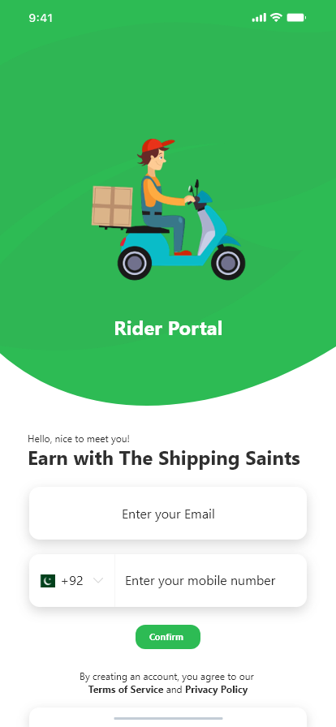

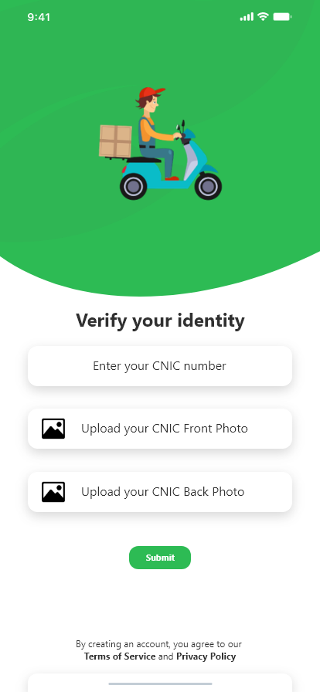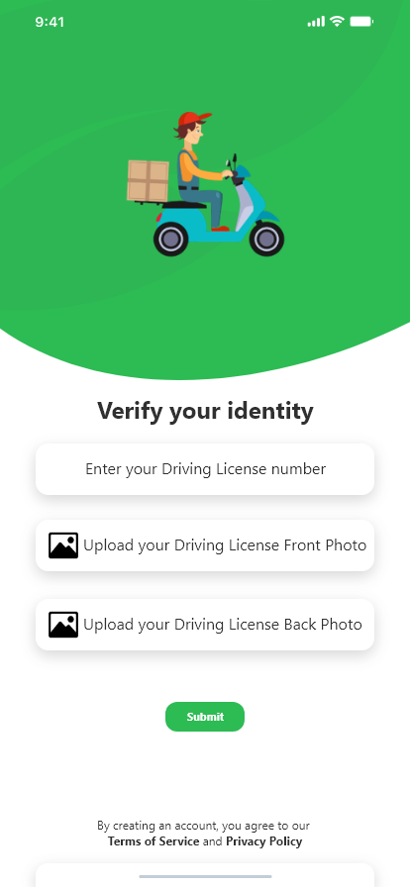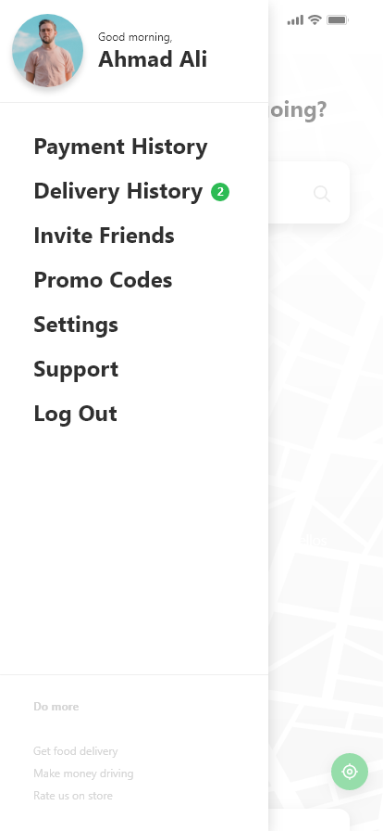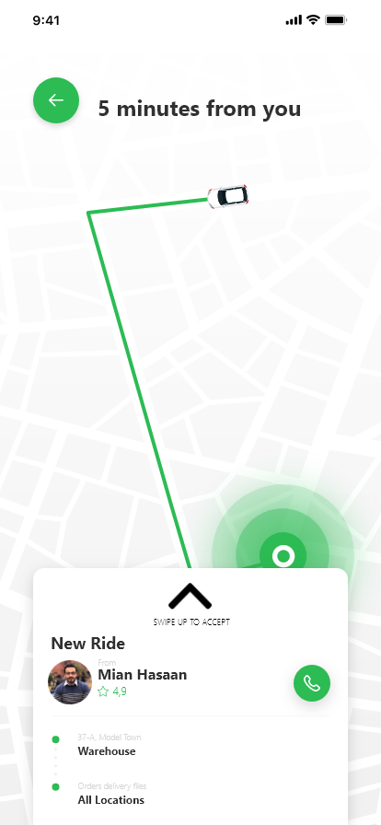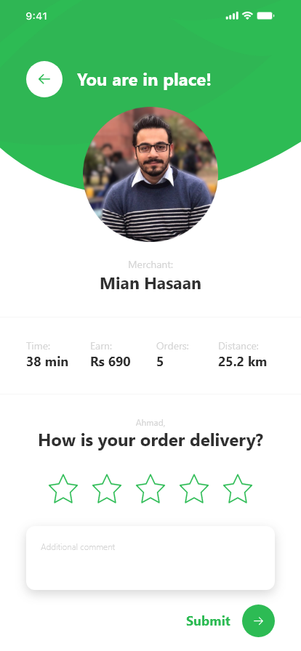

## Additional Information

<Any additional information>

# Other Design Details

<Describe any design details not covered in previous sections. Add subsections as required. There can be details regarding Research Oriented, Game Oriented, or Hardware based projects that have not been covered in this document before, those details can be provided in this section. For example research based projects may use this section to present their results and analysis; hardware based projects may use this section to describe interface dependencies and issues etc.>

# Revised Project Plan

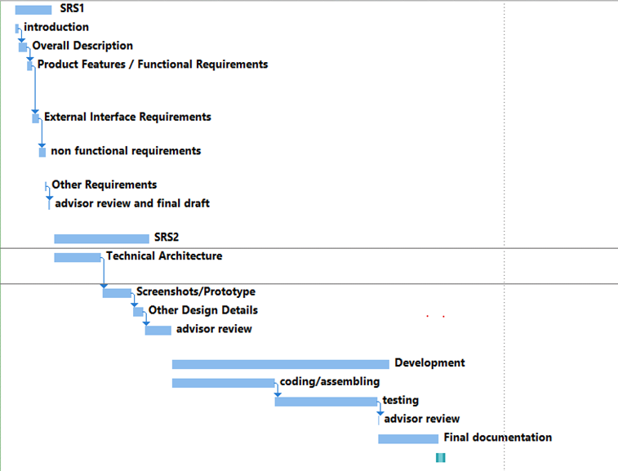

# References

<List all books, conference papers, journal articles, websites, etc. used in preparing the content of this SRS. Provide enough information so that the reader could access a copy of each reference, including title, author, volume/edition number, page number(s), and publication year. Mention complete URLs for websites.>

Appendix A: Glossary

<Define all the terms necessary to properly interpret the SRS, including acronyms and abbreviations. You may wish to build a separate glossary that spans multiple projects or the entire organization, and just include terms specific to a single project in each SRS.>

Appendix B: IV & V Report

**(Independent verification & validation)**

**IV & V Resource**

Name Signature

|  |  |  |  |  |  |
| --- | --- | --- | --- | --- | --- |
| **S#** | **Defect Description** | **Origin Stage** | **Status** | **Fix Time** | |
| **Hours** | **Minutes** |
| 1 |  |  |  |  |  |
| 2 |  |  |  |  |  |
| 3 |  |  |  |  |  |
| … |  |  |  |  |  |

**Table 1: List of non-trivial defects**

This document has been adapted from the following:

1. Previous project templates at UCP
2. High-level Technical Design, Centers for Medicare & Medicaid Services. ([www.cms.gov](http://www.cms.gov))